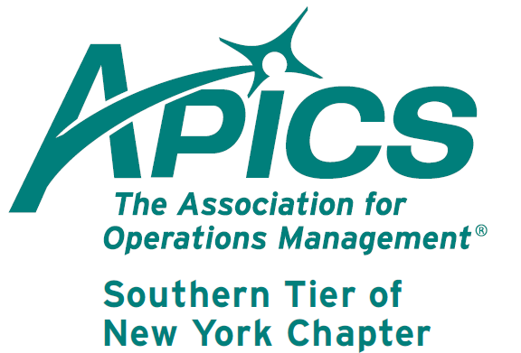
Notice New Name →→
←←Notice New Name
www.stapics.org

NEXT APICS NORTHEAST DISTRICT MEETING WILL BE RIGHT HERE
IN BINGHAMTON!!!

Have you always wanted to attend an APICS district meeting but didn’t want to drive for hours? Well, you wishes have been answered (and you’ve lost that excuse)!

The next district meeting will be on Nov 16-17 at the Holiday Inn in Binghamton.
Remember: You must pre-register at www.apicsnortheast.org in order to attend.

Full details and agenda information can be found at www.stapics.org.

Negotiation Skills: Basic Strategies to Achieve Your Goals!

This workshop will use experiential learning techniques to allow participants to identify, learn, and apply basic negotiation strategies and skills in both one-on-one situations as well as in teams.

ATTENDING THIS WORKSHOP WILL ENSURE WIN-WIN OUTCOMES FOR YOU, YOUR ORGANIZATION AND YOUR SUPPLY CHAIN PARTNERS!

Participants will discover how to:
- Analyze their own interests (what they want to achieve) as well as those of others
- Develop a position (what you tell the other party you want – not always the same as your actual interest!)
- Exchange information (and when to do so!)
- Make assessments and reach conclusions under time pressure
- Leverage their personality to be a better negotiator
- Avoid common pitfalls of negotiations

While this topic is often associated with the Purchasing or Sales functions, the strategies covered in this workshop would apply to all business functions:
- Marketing and Engineering negotiate new product releases and features
- Sales and Production negotiate master scheduling priorities
- Inventory and Finance negotiate inventory holdings
- Managers negotiate hiring, projects, budgets, work schedules, etc.

MANY ROUTINE CONVERSATIONS ARE IN FACT A NEGOTATION… WE’RE TRYING TO GET SOMETHING FROM ANOTHER PARTY, OR THEY’RE ASKING US FOR SOMETHING!

The participants will as well discover that the material applies to the relationships and situations they find outside of work.

Facilitator: Michael D. Ford, CSCP, CFPIM, CRE, CQE, CQA has presented over 250 public events across the US, Canada, Nigeria and South Africa. He has delivered over 4,000 classroom hours of training and maintains a 4.5/5.0 evaluation rating. Ford specializes in making training an “edu-taining” experience!

Date & Time: Friday, Nov. 16, 2012 from 12:30pm to 4:30pm

Location: Vestal Room, Holiday Inn Binghamton, 2-8 Hawley St., Binghamton NY 13901

RSVP: Register online at http://www.apics-buffalo.com/Events/Event_Registration.asp?id=241
Pay at door with checks payable to “APICS Buffalo”
Requests for information to michaeldford@earthlink.net or 607.624.4853

Fee: $79.00 per person for teams of 3 or more; $29.00 for full-time students (w/valid ID#)
$89.00 for members of APICS, ISM or ASQ (w/valid ID#); $99.00 for general public

Includes: 4 hours of interactive instruction, discussion and exercises
Break service to include coffee, soda and cookies
Certificate of completion
Proceedings article: “Building Basic Negotiation Skills: Accessing the Power Within”

We’re on !!!
Come and visit, poke around, or comment on us! Our name there is “Southern Tier APICS”. It’s just another way
for us to keep in touch with our membership.

Board of Directors 2012-2013

President Director of Publicity
Dave Gardner Kelly Norieka
dave@protofab25.com Kelly.norieka@lmco.com

Executive VP /Director of Finance Director of Education
Steve Whited Don Sheldon
steven.whited@acco.com dsheldon@sheldoninc.com

Secretary Director at Large
Debbie Unkel Steve Stanchak
deb.unkel@raymondcorp.com steve.stanchak@infoprint.com

Director of Membership/Director of Chapter Standards/

Director of Online Publication Director of Student Relations
Lee Schechter Brian Arrnold
lschechter@stny.rr.com barnold@amphenol-aao.com

Director of Programming and Marketing Director of Communications
Michael LoSapio April McWeeney
Michael.LoSapio@SynergyResources.net april.mcweeney@acco.com

Southern Tier APICS
PO Box 1107
Binghamton NY 13902-1107

